# Class 1

Variables and data types

# Class 2

## Review of class 1 content

# Class 3

## More about data variable

### Make a string variable that says ‘hello world’

s = ‘Hello World!’;

### make an array that consists of an integer, a decimal, and a string

array = [100, 3.1415, ‘my name is Jia Jia’];

print (array)

### Even and odd number

x = 100

if (x % 2 == 1) print(' odd')

if (x % 2 == 0) print ('even')

what will be printed?

# Class 4

## Introducing *if* – *else*

First control construct of the programming language. ***If*** means if something is true, ***else*** means not true then.

### If {then}

X = 123

If (x > 100) print(‘big’)

If (x < 100) print(‘small’)

If (x % 2 == 0) print (‘even’)

If (x %2 != 0) print(‘odd’)

### else {then}

In natural language, if-else express the statement about facts and action based on facts.

For example, ***if*** I feel tired, ***then*** I will go take a nap. ***If*** tomorrow it rains, (***then***) we will cancel the trip, or (***else***) we will start driving at 7.

In computer programming, if-else offers the ability to alter programming tract based on ***true*** or ***false*** of a ***logical statement.***

The difference is that in computer science, if-else-the is expressed by if statement:

***If*** (logical expression) { statement 1 } ***else*** {statement 2} [ ***statement*** vs. ***expression*** ]

| | | **|**

True/false true then false then

We can use something we already learned:

X = 1; y = 2; z = 3;

If (x > y) { print(‘x > y’) } else { print(‘x < y’) // any problem with it?

### Concepts: statement, expression, operators

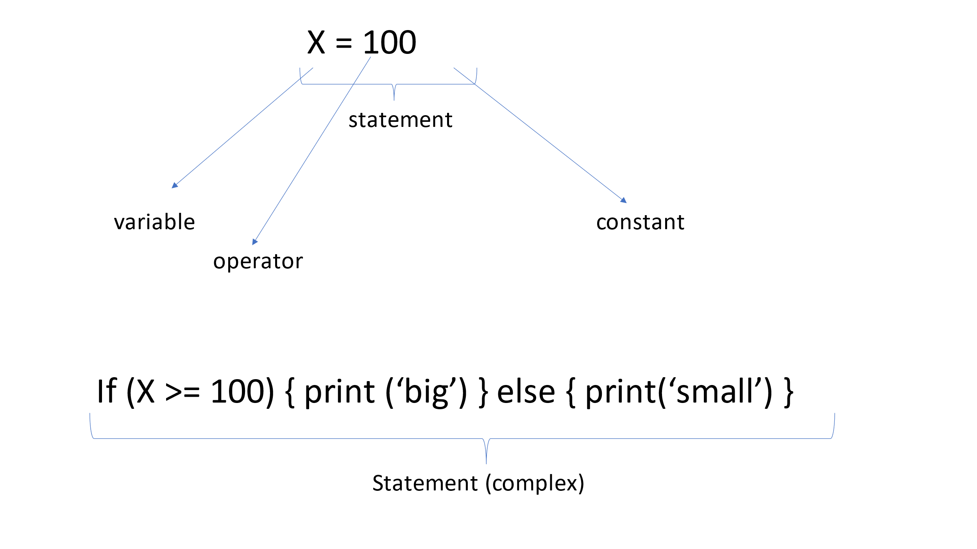

## Exercise:

Given two numbers x and y, if x >= y, print “x is bigger or equal than y”, otherwise print: “x is smaller than y”.

Given x, if x is even, print “x is even”, otherwise, print “x is odd”.

# Class 5

## Introducing *properties of a variable*

A variable can be thought as an “object” and it has “properties” or “attributes” such like those in nature.

For example, a human has properties, such as age, gender, weight, birthday, or birth-place.

An object has its own properties:

For example, a *string* has *length*, and an *array* also has *length*. They also have a kind of properties called *method*. A method can be thought of as “dynamic properties:, which has to be calculates.

For example, a string has a method, called *substring*, which calculates the part of a string. For example:

*s = “abcdef”;*

*sub_s = s.substring (1, 3);*

*print(sub_s);*

Try it.